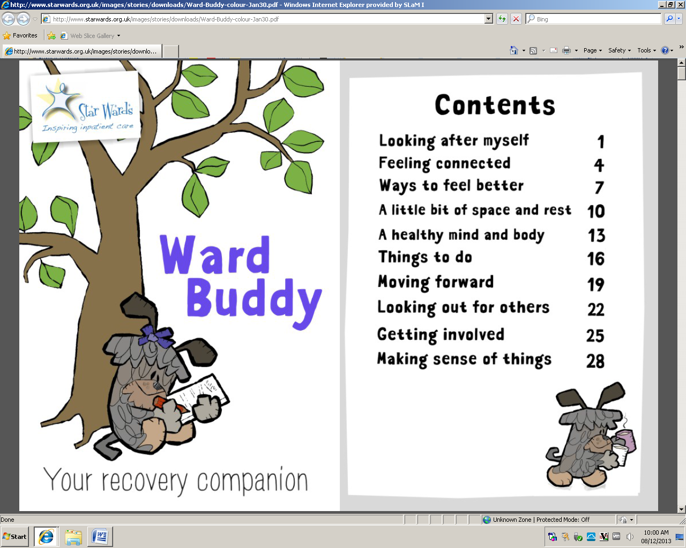
Your Recovery Guide and Companion



Developed by ASH Ward staff for Kent and Medway Adolescent Unit Woodland House

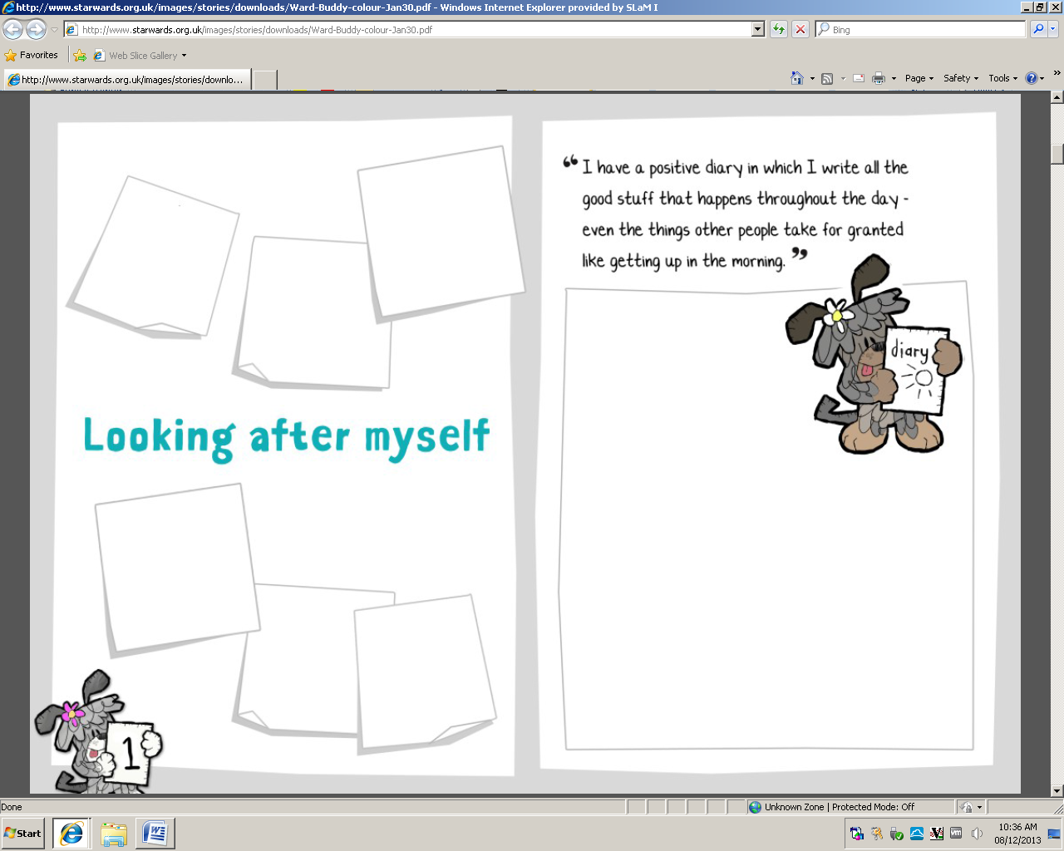
Hello – from Buddy and me! Buddy is my beloved Tibetan Terrier, a sweet, daft, adorable little hairy thing. As my support dog she comes with me on my many visits to wards, and her popularity with patients and staff inspired us to name our recovery companion after her – Ward Buddy. Just as she is very much my buddy, my funny little constant companion (which is also how she probably describes me!), Ward Buddy is designed to be a friendly, helpful presence to support people during their admission.
But the original Ward Buddy wasn’t as helpful as it could be for young people on a mental health ward and we were thrilled when Lisa, Amber and the team got in touch to see if we could develop something more suitable. Well, it turned out that they did all the work, with the invaluable input of young patients themselves. It’s incredibly tough being away from family, friends and pets when we’re in hospital and I’m so grateful to the Ash Ward team for creating such a wonderful, practical resource. Youth Ward Buddy will help so many young people have a more therapeutic and positive time in hospital.

Marion Janner OBE
Buddy’s mum, hospital patient and director of Star Wards


These are the people who manage my care while I am in hospital. I should know this within 3 days of my admission!
Doctors

Nurses

Support workers
Please add in your own appointments (e.g. Psychology, Family Therapy, 1:1 sessions, CPA meetings, etc.)
 | Monday | Tuesday | Wednesday | Thursday | Friday | Saturday | Sunday
Morning | Management Round | Meet with Dr Watts |  | Ward Round
Afternoon | 3-4pm Meet the Manager |  | Physical Health Clinic | Ward Round Feedback
Evening |  |  | Ward Round Requests

Allocated Nurse – This is the member of staff that is looking after you for that shift, this will not always be a member of your care team. This will include for 1-1 time. Please see allocation board near the ward entrance each shift.
Assessment – This could be a set of questions or a period of time when you mental wellbeing is being monitored to better inform us of your needs.
CAMHS – Child and Adolescent Mental Health Services. This can be both in the community and inpatient.
Care Coordinator – The nurse who is responsible for your care in the community.
Care Plan – This is the outline of the actions that staff will take with you when you are experiencing a specific problem. This plan will be made with you so your always involved.
Care Team – This is the nursing staff who are responsible for your care during your stay.
Charge Nurse – A senior nurse.
Community Meeting – A meeting for all the young people to discuss any issues on the ward. These are written on the ward timetable.
CPA – Care Programme Approach. This a meeting between all the professionals involved in your care (this will include your community team, school and any other outside agencies) to discuss your progress and future plans for your care. You and your family are also invited to attend.
De-escalation Room – A safe place on the unit where you can go when you are distressed.
Discharge – This is when your stay in hospital comes to an end.
ECG – Electrocardiogram. This is a way of monitoring your hearts activity, generally done in the admission period.
IM – Intramuscular injection.
Informal – You have agreed to come and stay in hospital for a period.
Inpatient – When you stay in hospital
Management Round – Weekly meeting on a Monday between medical, nursing and education staff.
MDT – Multi-disciplinary Team. This term refers to all members of the Woodland House staff.
Medication Round – This is when prescribed medication is given, generally in the morning, afternoon and evening.
Observation Level – This refers to how regularly a member of staff will observe your whereabouts, this is documented. You will be made aware what observation level you are on and the reason behind this will be explained.
Occupational Therapy (OT) – A therapy that looks into your everyday activities and skill set.
Parental Consent – When your parents consent to you being in hospital, you may not always agree with this decision. This relates to under 16s only.
Physical Health Observations (MEWs) – This is when a member of nursing staff takes your pulse, blood pressure, temperature, breathing, blood oxygen, blood sugar levels and weight.
Primary Nurse – The main nurse responsible for your care on the ward.
Reintegration – Process of you going back to your usual school.
Risk – A situation when you might put yourself or others in harms way. This can be on purpose or by accident.
Section – This means you have been admitted to hospital against your will. This is under a legal framework and does mean there are restrictions for you on the ward.
Staff Nurse – A junior nurse.
Support Worker – A junior member of the nursing team.
1:1 Time – This is a dedicated period of time for you to discuss any problems with your allocated nurse; this can be formal or informal depending on your wishes.
Trigger – Events that could lead to you becoming distressed.
UDS – Urine Drug Screen.
Ward Round – A weekly meeting held on a Thursday between the MDT to discuss your care and future plans for care. You can make requests for consideration and you will be given feedback on what has been talked about.
YP – Young Person/People

I like…
Who are you? What do you like?
I am a…

…………………
Son Music
Daughter Animals
Brother Volunteering
Sister Sports
Friend Socializing
Best Friend Films
Girlfriend Books
Boyfriend Art
…………………
…………………
…………………
…………………
…………………
…………………
…………………
…………………
…………………
…………………
…………………
…………………
…………………
…………………
…………………
…………………
…………………
…………………
…………………
…………………
…………………
…………………
…………………

Talkative
Easy Going
Curious
Outgoing
Loud
Adventurous
Friendly
……………...
Quiet
Supportive
Happy
Serious
Energetic
Enthuastic
Opinionated
Hard Working
Impulsive
Thoughtful
Introverted
Encouraging
Brave
Responsible
Supportive
Social
Extroverted
Confident
Confident
……………...
……………...
……………...
……………...
……………...
……………...
……………...
……………...
……………...
……………...
……………...
……………...
……………...
……………...
……………...
……………...
……………...
……………...
……………...
……………...
……………...
……………...

Why am I in hospital?
Think about what happened in the week before you were admitted. What do you think led to your admission to hospital?

Think about what you want to achieve during admission?
Personal Goal
Who Can Support me?
How do I think I can make this happen?

Plot on this road where you are now and where you would like to be. Write or draw goals to get between the points. Make it as colourful and creative as you like!

Month:
Year:
Date
Green
good
Red
Bad Mood
Amber
Not great
Medication
Notes

1 | 2 | 3 | 4 | 5 | 6 | 7 | 8 | 9 | 10 | 11 | 12 | 13 | 14 | 15 | 16 | 17 | 18 | 19 | 20 | 21 | 22 | 23 | 24 | 25 | 26 | 27 | 28 | 29 | 30 | 31

What stuff makes you feel a negative emotion?

I am your stress bucket, write on my label stuff that makes you feel bad. Once you’ve done that, have a think about things that help you fight feeling bad. Draw holes in my side with water pouring out, in the stream of water, write the action you take to fight bad feelings. Each method of making you feel better is a hole and a stream of water...to stop me from over flowing!

Stuff that makes me feel bad…
...................................................................................................................................................................................................................................................................................................................................................................................................................................................................................................................


Drawing
Talking
Music
Reading
Writing
The ‘Song Title’ is a thought or an issue, e.g. self harm or hearing voices. In between the lines of the musical score write things that help distract you from those thoughts or the issue. The musical notes suggest techniques of distraction.
Song Title:
Song Title:
Song Title:

Useful Relaxation Techniques
Simple Breathing Exercise:
- Where ever you are, e.g. during meetings or groups, in the de-escalation room or before bed.
- Stop
- Shoulders down
- Take 2 or 3 slightly slower, slightly deeper out breaths
- Carry on with what you were doing but just a little slower!
Count to 10:
- Each in breath counts as 1, count to 10.
- Then, each out breath counts as 1, count to 10.
- Then, each breath (in or out) counts as 1, count to 10 again.
…………………………………………
…………………………………………
…………………………………………
…………………………………………
…………………………………………

Things that help me relax…
…………………………………………..
………………………………………….
…………………………………………
…………………………………………

TRIGGER ACTIONS

Plot on this road where you are now and where you would like to be. Write or draw goals to get between the points. Make it as colourful and creative as you like!

What effects my mental health
Awareness of things/situation that may be unhelpful to me keeping well

What did not help me/made things worse during my admission?
What helped me during my admission?
How I can move on positively from my admission…
Why was I admitted…?

This clock represents your admission from beginning to end. Fill in each segment of the clock face with reflections about your admission and things you have learnt during your time here. Plot on the clock where you would place your admission and where you would place your discharge. Next fill in anything in-between and/or after.
12
1
2
3
4
5
9
8
7
6
10
11

Plot on this road where you are now and where you would like to be. Write or draw goals to get between the points. Make it as colourful and creative as you like!

What do you want in your future and how can you make it happen? The goals do not have to be long term if you don’t want them to be! The scrolls represent the ultimate goals, while the ladders show the practical things you need to do to get there…

………………
………………
………………
………………
………………
………………
………………
………………
………………
………………
………………
Skipping School
Sleeping all day
Putting on weight
Depressed
Moody
Lonely
Bad thoughts
Feeling down
Losing Weight
Not going out
Not eating
Isolating myself
Quiet
Light headed
Always crying
Frightened
Annoyed
Angry
Scared
Not being in control
Alone
Feeling sick all the time
Self harming more
Anxiety
Panic

Who can help me…
What I will do if I’m becoming unwell…

What doesn’t help me…
What helps me…

- Useful Numbers:
Samaritans: 08457 90 90 90
Childline: 0800 11 11
Family, Carers and Friends
……………………………………………………………………………………………………………………………………………………………………………………………………………………………………………………………………………………………………………………………………………………………………………………………………………………………………………………………..
A & E Departments
QEQM: St Peters Rd, Margate, Kent CT9 4AN
William Harvey Hospital: Kennington Rd, Willesborough, Ashford, Kent TN24 0LZ

Tunbridge Wells Hospital: Tonbridge Rd, Pembury, Tunbridge Wells TN2 4QJ ‎
Medway Maritime: Windmill Rd, Gillingham ME7 5NY
My Social Worker is: ………………………………………………….
Contact No.: ………………………………………………………….

My GP is: …………………………………………………………..
…………………………………………………………………………………………………………………………………………………………………………………………………………
My Care Coordinator is:
……………………………………………………………
CAMHS List
Dover: Castleside Clinic, Dover Health Centre, Dover
CT16 1RH. Tel.: 0300 300 1987
Folkestone: Cherry Tree House, Cheriton High St.,
Folkestone CT18 8AN.
Tel.: 0300 300 1988
Canterbury: Georges Turle House, 54 London Road,
Canterbury CT2 8JY.
Tel.: 0300 300 1984
Ashford: Lenworth Clinic, 329 Hythe Road, Ashford
TN24 0QE.
Tel.: 0300 300 1982
Thanet: Orchard House, 17 Church Street, St Peters,
Broadstairs CT10 2TT.
Tel.: 0300 300 1983
Medway and Swale: Canada House, Barnsole Road,
Gillingham ME7 4JL.
Tel.: 0300 300 1989
Dartford: 1 Twistleton Court, Priory Hill, Dartford
DA2 2EN. Tel.: 0300 300 1986
Maidstone: Knight Rider House, Knight Rider Street,
Maidstone ME15 6LU. Tel.: 0300 300 1990



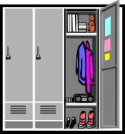



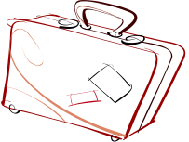
School books?
Ward buddy?
Hair dryer/straighteners?
Call parents to confirm?
Taken things out of locker?
TTO’s?
Clothes packed?
Discharge Checklist
Have I got everything?
My Discharge day is: ……………………………………………………………………
I am leaving at: …………………………….
Who is picking me up? ………………………………………………………………….
I am being discharged to (address): …...............................................
………………………………………………………………………………………………………………………………………………………………………………………………………………
The plan of the day is:
………………………………………………………………………………………………………………………………………………………………………………………………………………………………………………………………………………………………………………………………………………………………………………………………………………………………………………………………………………………………………………………………………………………………………………………………………………………………………………………………………………………………………………………………………………………………………………………………………………………………………………………………
My follow up appointment with my local CAMHS team will be on:
………………………………………………………………………………………………………
I will be visited by: ……………………………………………………..........

Night
Evening
Afternoon
Morning
My Medication:
Day 1
………………
Day 3
………………
Day 4
………………
Day 5
………………
Day 6
………………
Day 7
………………
Day 2
………………

Plot on this road where you are now and where you would like to be. Write or draw goals to get between the points. Make it as colourful and creative as you like!

